DATA FOR THE SPANISH MODEL

All the data except the series LFSQ_EWHAIS is extracted from: <https://fred.stlouisfed.org/>

**CLVMNACSCAB1GQES**

**Real Gross Domestic Product for Spain, Euros of Chained 2010 Euros, Quarterly, Seasonally Adjusted**

**ESPGDPDEFQISMEI**

**GDP Implicit Price Deflator in Spain, Index 2015=100, Quarterly, Seasonally Adjusted**

**ESPPFCEQDSMEI**

**Private Final Consumption Expenditure in Spain, Euros, Quarterly, Seasonally Adjusted**

**ESPGFCFQDSMEI**

**Gross Fixed Capital Formation in Spain, Euros, Quarterly, Seasonally Adjusted**

**LFEMTTTTESQ647S**

**Employed Population: Aged 15 and Over: All Persons for Spain, Persons, Quarterly, Seasonally Adjusted**

**LFEMTTTTESQ647SIndex: Elaborated by me, 2015 = 100**

**IR3TIB01ESQ156N**

**3-Month or 90-day Rates and Yields: Interbank Rates for Spain, Percent, Quarterly, Not Seasonally Adjusted**

**LFWA64TTESQ647S**

**Working Age Population: Aged 15-64: All Persons for Spain, Persons, Quarterly, Seasonally Adjusted**

**LFWA64TTESQ647SIndex: Elaborated by me, 2015 = 1**

**LCEATT01ESQ661S**

**Hourly Earnings: All Activities for Spain, Index 2015=100, Quarterly, Seasonally Adjusted**

LFSQ_EWHAIS

Average number of actual weekly hours of work in main job. Total,

Source of data: Eurostat

**LFSQ_EWHAISIndex: Elaborated by me, 2015 = 100**

Definition of data variables:

Definition of data variables

**Consumption** = LN ((ESPPFCEQDSMEI/ESPGDPDEFQISMEI)/ LFWA64TTESQ647SIndex) *100

**Investment** = LN ((ESPGFCFQDSMEI/ ESPGDPDEFQISMEI)/ LFWA64TTESQ647SIndex) *100

**Output** = LN ((CLVMNACSCAB1GQES/ LFWA64TTESQ647SIndex) *100

**Hours**= LN ((LFSQ_EWHAISindex* LFEMTTTTESQ647SIndex/100)/ LFWA64TTESQ647SIndex) *100

**Inflation** = LN(ESPGDPDEFQISMEI/ESPGDPDEFQISMEI (-1)) *100

**Real** wage = LN(LCEATT01ESQ661S)/(ESPGDPDEFQISMEI)*100

**Interest** **rate** = IR3TIB01ESQ156N/4

**DATA FOR THE US MODEL**

**Data documentation: see usmodel_data.xls and usmodel_data.mat**

Definition of data variables

consumption = LN ((PCEC / GDPDEF) / LNSindex) * 100

investment = LN ((FPI / GDPDEF) / LNSindex) * 100

output = LN (GDPC96 / LNSindex) * 100

hours = LN ((PRS85006023 * CE16OV / 100) / LNSindex) * 100

inflation = LN (GDPDEF / GDPDEF (-1)) * 100

real wage = LN (PRS85006103 / GDPDEF) * 100

interest rate = Federal Funds Rate / 4

Source of the original data

GDPC96: Real Gross Domestic Product - Billions of Chained 1996 Dollars, Seasonally Adjusted Annual Rate

Source: U.S. Department of Commerce, Bureau of Economic Analysis

GDPDEF: Gross Domestic Product - Implicit Price Deflator - 1996=100, Seasonally Adjusted

Source: U.S. Department of Commerce, Bureau of Economic Analysis

PCEC: Personal Consumption Expenditures - Billions of Dollars, Seasonally Adjusted Annual Rate

Source: U.S. Department of Commerce, Bureau of Economic Analysis

FPI: Fixed Private Investment - Billions of Dollars, Seasonally Adjusted Annual Rate

Source: U.S. Department of Commerce, Bureau of Economic Analysis

CE16OV: Civilian Employment: Sixteen Years & Over, Thousands, Seasonally Adjusted

Source: U.S. Department of Labor: Bureau of Labor Statistics

CE16OV index: CE16OV (1992:3) =1

Federal Funds Rate: Averages of Daily Figures - Percent

Source: Board of Governors of the Federal Reserve System

(Before 1954: 3-Month Treasury Bill Rate, Secondary Market Averages of Business Days, Discount Basis)

LFU800000000: Population level - 16 Years and Older - Not Seasonally Adjusted

Source: U.S. Bureau of Labor Statistics

LNS10000000: Labor Force Status: Civilian noninstitutional population - Age: 16 years and over - Seasonally Adjusted - Number in thousands

Source: U.S. Bureau of Labor Statistics

(Before 1976: LFU800000000: Population level - 16 Years and Older)

LNSindex: LNS10000000(1992:3) =1

PRS85006023 - Nonfarm Business, All Persons, Average Weekly Hours Duration: index, 1992 = 100, Seasonally Adjusted

Source: U.S. Department of Labor

PRS85006103 - Nonfarm Business, All Persons, Hourly Compensation Duration: index, 1992 = 100, Seasonally Adjusted

Source: U.S. Department of Labor

NOTES ON THE DATA

* In the excel data of Smets and Wouters, the inflation is computed as reflected in my formula. However, in his file explaining the data he states that inflation is calculated under the inflation formula provided in data for US model.
* The red highlights in my series provides differences with the data of S&W07
* I had a mistake on computing one of my indexes, now is corrected.
* I believe it may be a mistake that my GDP units are in millions while my gross fixed capital formation and private final consumption expenditure are in euros. Is that a problem?

After this changes, my next step is to reconstruct the .mat file with the updated variables. Then I will recompute the matrixes of correlation for the US and ESP data.

Finally, I will re-plot the graphs.

After plotting the matrix of correlations, I have seen and improvement on the data respect the wrong previous data. However, it seems that the variables “*labobs”* (log of hours worked) and “*dw*” (wage growth rate) are creating a problem on my data respect the S&W07:

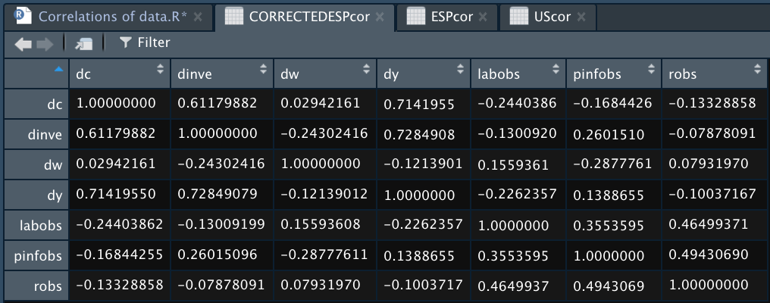

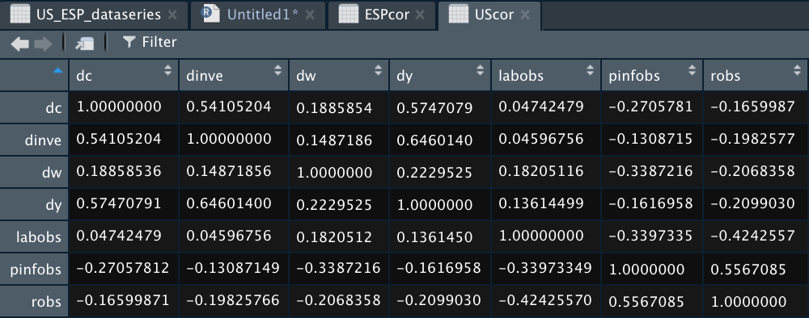

Because the results were weird if have revised the data and discovered that the output was not deflated by the GDP deflator when calculated. Correcting this mistake and computing the correlation matrix give me:

